Thursday July 28, 2022
Ref: KWSG/IIH/2022/07/011
Mr Kazeem Oladepo,
Vice President,
IHS Nigeria,
Plot 934 Idejo Street,
Off Adeola Odeku,
Victoria Island, Lagos.
Dear Sir,
INVITATION TO A MEETING ON PROPOSED ILORIN SMART CITY
Sequel to our recent coversations
Yours truly,
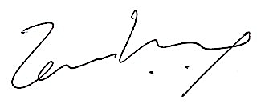
Temi Kolawole
Managing Director
Ilorin Innovation Hub

